EXPERIMENTS

NAME:BHARANI DHARAN S
REG NO:192424141
COURSE CODE:DSA0602 DATA HANDLING AND VISUALIZATION

SET 9 – ONLINE LEARNING ACTIVITY ANALYSIS

Student_ID | Gender | Age | Course | Study_Time (hrs) | Videos_Watched | Quiz_Score | Login_Date
L01 | Male | 20 | R | 3.5 | 12 | 78 | 2025-01-05
L02 | Female | 22 | R | 4.2 | 15 | 85 | 2025-01-05
L03 | Male | 19 | SQL | 2.0 | 8 | 65 | 2025-02-08
L04 | Female | 21 | R | 5.0 | 18 | 92 | 2025-02-08
L05 | Male | 23 | R | 2.5 | 9 | 70 | 2025-03-12
L06 | Female | 20 | SQL | 4.0 | 14 | 88 | 2025-03-12

Import the dataset in R. Plot a histogram for Quiz_Score. Draw a boxplot of Quiz_Score by Course. Add title and labels. Interpret student performance.

AIM
To analyze the distribution of quiz scores using a histogram and compare quiz scores across different courses using a boxplot.

PROCEDURE
- Create or import the Online Learning Activity dataset.
- Store the student information in R.
- Plot a histogram for Quiz_Score.
- Plot a boxplot of Quiz_Score by Course.
- Add suitable titles and labels.
- Interpret the student performance.

CODE

data <- data.frame(
Student_ID = c("L01","L02","L03","L04","L05","L06"),
Gender = c("Male","Female","Male","Female","Male","Female"),
Age = c(20,22,19,21,23,20),
Course = c("R","R","SQL","R","R","SQL"),
Study_Time = c(3.5,4.2,2.0,5.0,2.5,4.0),
Videos_Watched = c(12,15,8,18,9,14),
Quiz_Score = c(78,85,65,92,70,88),
Login_Date = c("2025-01-05","2025-01-05","2025-02-08",
"2025-02-08","2025-03-12","2025-03-12")
)

hist(
data$Quiz_Score,
main = "Distribution of Quiz Scores",
xlab = "Quiz Score",
ylab = "Frequency"
)

boxplot(
Quiz_Score ~ Course,
data = data,
main = "Quiz Score by Course",
xlab = "Course",
ylab = "Quiz Score"
)
OUTPUT

RESULT
Thus, the histogram and boxplot were successfully created and student quiz performance was analyzed.

QUESTION 2
Create a scatter plot using R programming between Study_Time and Quiz_Score. Represent Videos_Watched using bubble size. Apply transparency. Explain the learning pattern.

AIM
To analyze the relationship between study time and quiz score using a bubble scatter plot.

PROCEDURE
- Create the online learning dataset.
- Use Study_Time on the X-axis.
- Use Quiz_Score on the Y-axis.
- Represent Videos_Watched using bubble size.
- Apply transparency to the bubbles.
- Add title and axis labels.
- Interpret the learning pattern

CODE
data <- data.frame(
Student_ID = c("L01","L02","L03","L04","L05","L06"),
Gender = c("Male","Female","Male","Female","Male","Female"),
Age = c(20,22,19,21,23,20),
Course = c("R","R","SQL","R","R","SQL"),
Study_Time = c(3.5,4.2,2.0,5.0,2.5,4.0),
Videos_Watched = c(12,15,8,18,9,14),
Quiz_Score = c(78,85,65,92,70,88)
)

symbols(
data$Study_Time,
data$Quiz_Score,
circles = data$Videos_Watched,
inches = 0.4,
bg = adjustcolor("blue", alpha.f = 0.4),
fg = "blue",
xlab = "Study Time (hours)",
ylab = "Quiz Score",
main = "Study Time vs Quiz Score"
)
OUTPUT

RESULT
Thus, the relationship between study time, videos watched and quiz score was successfully visualized using a bubble scatter plot.

QUESTION 3
Using R programming, convert Login_Date into Date format. Calculate average quiz score per month. Plot a line chart. Apply moving average smoothing. Identify the trend.

AIM
To analyze the monthly average quiz score and identify the performance trend using a moving average line.

PROCEDURE
- Create the online learning dataset.
- Convert Login_Date into Date format using as.Date().
- Extract the month from the login date.
- Calculate the average quiz score for each month.
- Calculate a moving average.
- Plot the monthly average score as a line chart.
- Add the moving average line.
- Identify the trend.

CODE
data <- data.frame(
Student_ID = c("L01","L02","L03","L04","L05","L06"),
Gender = c("Male","Female","Male","Female","Male","Female"),
Age = c(20,22,19,21,23,20),
Course = c("R","R","SQL","R","R","SQL"),
Study_Time = c(3.5,4.2,2.0,5.0,2.5,4.0),
Videos_Watched = c(12,15,8,18,9,14),
Quiz_Score = c(78,85,65,92,70,88),
Login_Date = c("2025-01-05","2025-01-05","2025-02-08",
"2025-02-08","2025-03-12","2025-03-12")
)

data$Login_Date <- as.Date(data$Login_Date)

data$Month <- format(data$Login_Date, "%Y-%m")

monthly_avg <- aggregate(
Quiz_Score ~ Month,
data = data,
FUN = mean
)

monthly_avg$Moving_Average <- stats::filter(
monthly_avg$Quiz_Score,
rep(1/2, 2),
sides = 1
)

plot(
1:nrow(monthly_avg),
monthly_avg$Quiz_Score,
type = "o",
xlab = "Month",
ylab = "Average Quiz Score",
main = "Monthly Average Quiz Score",
xaxt = "n"
)

axis(
1,
at = 1:nrow(monthly_avg),
labels = monthly_avg$Month
)

lines(
1:nrow(monthly_avg),
monthly_avg$Moving_Average,
type = "o"
)

legend(
"topleft",
legend = c("Average Quiz Score", "Moving Average"),
lty = 1,
pch = 1
)
OUTPUT

RESULT
Thus, the login dates were converted into Date format, monthly average quiz scores were calculated, and the trend was successfully visualized using a line chart with moving average smoothing.

QUESTION 4

Import Online_Learning_Activity.csv into Tableau. Create a bar chart showing average quiz score by Course. Create a scatter plot (Study Time vs Quiz Score). Add filter for Gender and Course. Design a mini interactive dashboard.

AIM

AIM
To create an interactive online learning activity dashboard using R programming with a bar chart, scatter plot, and filters for Gender and Course.

PROCEDURE
- Create the Online Learning Activity dataset.
- Load the shiny package.
- Create a bar chart for average quiz score by course.
- Create a scatter plot between Study Time and Quiz Score.
- Represent Videos Watched using bubble size.
- Add Gender and Course filters.
- Display the charts and student data in an interactive dashboard.
- Run the Shiny application.

CODE
library(shiny)

data <- data.frame(
Student_ID = c("L01","L02","L03","L04","L05","L06"),
Gender = c("Male","Female","Male","Female","Male","Female"),
Age = c(20,22,19,21,23,20),
Course = c("R","R","SQL","R","R","SQL"),
Study_Time = c(3.5,4.2,2.0,5.0,2.5,4.0),
Videos_Watched = c(12,15,8,18,9,14),
Quiz_Score = c(78,85,65,92,70,88),
Login_Date = c("2025-01-05","2025-01-05","2025-02-08",
"2025-02-08","2025-03-12","2025-03-12")
)

ui <- fluidPage(
titlePanel("Online Learning Activity Dashboard"),

sidebarLayout(
sidebarPanel(
selectInput(
"gender",
"Select Gender:",
choices = c("All", "Male", "Female")
),

selectInput(
"course",
"Select Course:",
choices = c("All", "R", "SQL")
)
),

mainPanel(
plotOutput("barPlot"),
plotOutput("scatterPlot"),
tableOutput("dataTable")
)
)
)

server <- function(input, output) {

filteredData <- reactive({
result <- data

if (input$gender != "All") {
result <- result[result$Gender == input$gender, ]
}

if (input$course != "All") {
result <- result[result$Course == input$course, ]
}

result
})

output$barPlot <- renderPlot({

result <- filteredData()

avg_score <- aggregate(
Quiz_Score ~ Course,
data = result,
FUN = mean
)

barplot(
avg_score$Quiz_Score,
names.arg = avg_score$Course,
xlab = "Course",
ylab = "Average Quiz Score",
main = "Average Quiz Score by Course"
)
})

output$scatterPlot <- renderPlot({

result <- filteredData()

symbols(
result$Study_Time,
result$Quiz_Score,
circles = result$Videos_Watched,
inches = 0.4,
bg = adjustcolor("blue", alpha.f = 0.4),
fg = "blue",
xlab = "Study Time (hrs)",
ylab = "Quiz Score",
main = "Study Time vs Quiz Score"
)
})

output$dataTable <- renderTable({
filteredData()
})
}

shinyApp(ui = ui, server = server)

OUTPUT
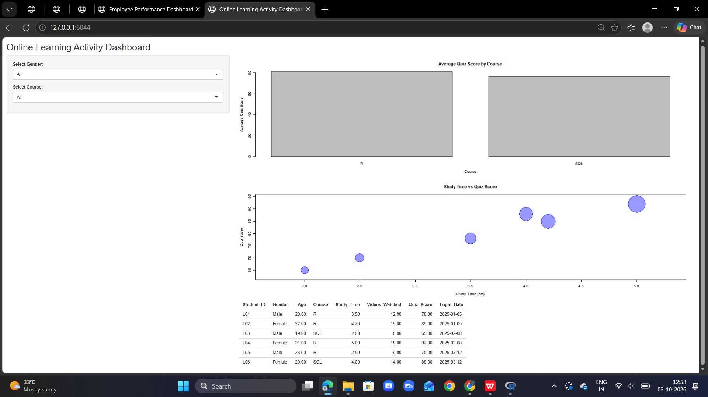

RESULT
Thus, an interactive Online Learning Activity Dashboard containing the average quiz score bar chart, study-time scatter plot, filters and data table was successfully created using R Shiny.

